**------------------------------------------------------------DESIGN 1------------------------------------------------------------**

**Description:**

* 1 person sits/stands on one side of the machine with the box of wine pouches ready to go at their side, and loads the wine pouches (with their caps still on) into slots like the astrofill has, and the pouches will rest on a conveyer-belt which will circle down the machine, carrying pouches from one station to the next
  + Volunteer loads pouch by sliding cap into holder where some sort of clamp is activated by the volunteer to hold the pouch in place (simple spring? Or something that will allow machine to detect whether a pouch is there or not?)
  + Once pouches have been loaded, 1st volunteer hits button that signals the machine to move again (machine also waits for 2nd volunteer to hit button-both must be hit before machine will move)
* The conveyer belt will move at a relatively slow speed, but it will be programmed to stop every 3rd station to pause and wait for the other stations to send a signal that they have completed their operations.
  + Is it possible to have conveyer belt be a “V” shape when you look down it so that way it can direct spillage to the middle of the belt where there is perhaps a drain that will drain any spillage into a collection pan underneath the belt?
  + If not, will need a large spillage collection pan to do underneath the belt
  + Actually, Matthew was saying a large collection pan underneath the entire machine would be helpful since when they spray and wipe down the machine, the water will have to drain somewhere
  + Perhaps have the drainage be directed into a container that can be removed/dumped out? Ask Matthew how much drainage they need to accommodate-is it worth it to put the drainage into a small volume container or should we just keep the pan general and have one output hole where he can twist it to drain the pan?
* The volunteer will insert 3 pouches into separate holders (next to each other) and the conveyer belt will then move down the line 2 stations (bringing those 3 empty pouches to the N2 puff and giving the volunteer 3 new slots to put more pouches in
* This was done because I am guessing it will take ~20-30 seconds to open / fill each pouch with N2 and wine, so that will be about the pause time that the conveyer belt will wait for, so in order for us to meet our productivity goal we should have the volunteer doing at least 3 pouches every interval so that we are producing 2 pouches every interval (3pouches/30 seconds *3600seconds/1 hr = 360 pouches / hr)
  + At stations 4-6, machine will sense whether or not a pouch is present in the clamp
    - Or, what if the volunteer will push a button for every pouch that they load and the machine remembers these button pushes and correlates them with which pouch to fill?
    - Or maybe if the clamp is closed then it will register a pouch being there but if it is open then the machine will know there’s not a pouch there
  + If a pouch is sensed, machine will have mechanism search for correct orientation of lid, rotate to match, and remove lid (program mechanism to remember the location of the pouch holder/clamp)
  + Mechanism that puffs nitrogen operates
    - Something is programmed to switch the valve on the N2 tube, wait a certain amount of time, then switch it off again
    - Probably would be better that it has to apply pressure the whole time it wants the N2 to be flowing and the valve closes again as soon as the pressure is relieved
  + Mechanism that fills wine operates
    - Same concept as above, something applies pressure to open the valve of wine and removes pressure when it is time to stop filling
  + Mechanism with lid snaps cap back on
  + Wine pouch is assessed for spillage…during testing this will be done, not during regular operation
  + 2nd volunteer releases clamp and offloads pouch
  + 2nd volunteer presses button that signals machine to rotate again
* There will be 6 stations total (the first three for the volunteer to insert the pouch in, the next three to have cap removed, open with N2 puff, fill with wine, snap cap back on, release pouch)
* 2nd volunteer will be sitting in front of the last three stations to offload the pouches and put them into boxes to be transported

**Relevant Sketches:**

**--------------------------------------------------------- END OF DESIGN 1---------------------------------------------------------**

**------------------------------------------------------------DESIGN 2------------------------------------------------------------**

**Description:**

* Machine is circular with inner part of machine being able to rotate to different stations to dispense N2 and wine
* 1 volunteer will circle around machine attaching wine pouches to slots and offloading filled bags (they can go at their own rate, don’t have to wait for machine to fill up (depending on size of machine, optimize # of stations
* Once volunteer slides pouch into slot (much like the astrofill slot) with clamp, they push a button that it is secure and machine starts process of:
  + Identifying / orienting / removing lid from pouch
    - Mechanical arm will do this with memory for where the lid will snap back onto and ability to identify which way the cap should be facing, rotate to match this, then rotate again to snap it on in correct manner
  + Delivering puff of N2
  + Delivering volume of wine
    - The N2 and the wine nozzles are small enough and right next to each other that they both dispense into the pouch hole (or, if not, adjust design so that they experience a slight shift to make themselves centered on the pouch hole when it is their turn to operate)
  + Snapping lid back on
  + Releasing clamp holding wine pouch in place
  + Pouch sits here waiting until volunteer comes around again, offloads the pouch, and reloads another one
* Tubes attaching to N2 and wine sources come out the bottom of the machine and have….something…that prevents twisting of tubes as machine rotates around
* 2nd volunteer does the labelling

**Relevant Sketches:**

**--------------------------------------------------------- END OF DESIGN 2--------------------------------------------------------**

**Description:**

1. Loading mechanism
   1. Hook is pushed under stack that is inside mab/loading box
   2. Hook grabs 1 pouch and pulls into pouch holder
   3. Pouch holder is attached to chain or linkage of some sort that moves pouch holder.
2. Linkage
   1. Linkage of some sort moves the pouch holder around. Later a cam system will be discussed that is integrated into this system
3. Fill Head aparatus
   1. Fill head apparatus holds all the fill heads
   2. Apparatus spins to allow for each head to operate
   3. Moves up and down, and turns for filling
   4. Cap Apparatus
      1. Takes cap off, moves cap out of the way, fills pouch with product, then puts cap back on.
   5. N2 head
      1. Has a rubber seal so that N2 cannot escape the pouch
   6. Fill head is just a tube
4. Cam Driven Pouch Holder
   1. The pouch holder is driven by a cam system that is integrated into the linkage.
5. Spinning Containment Bay?

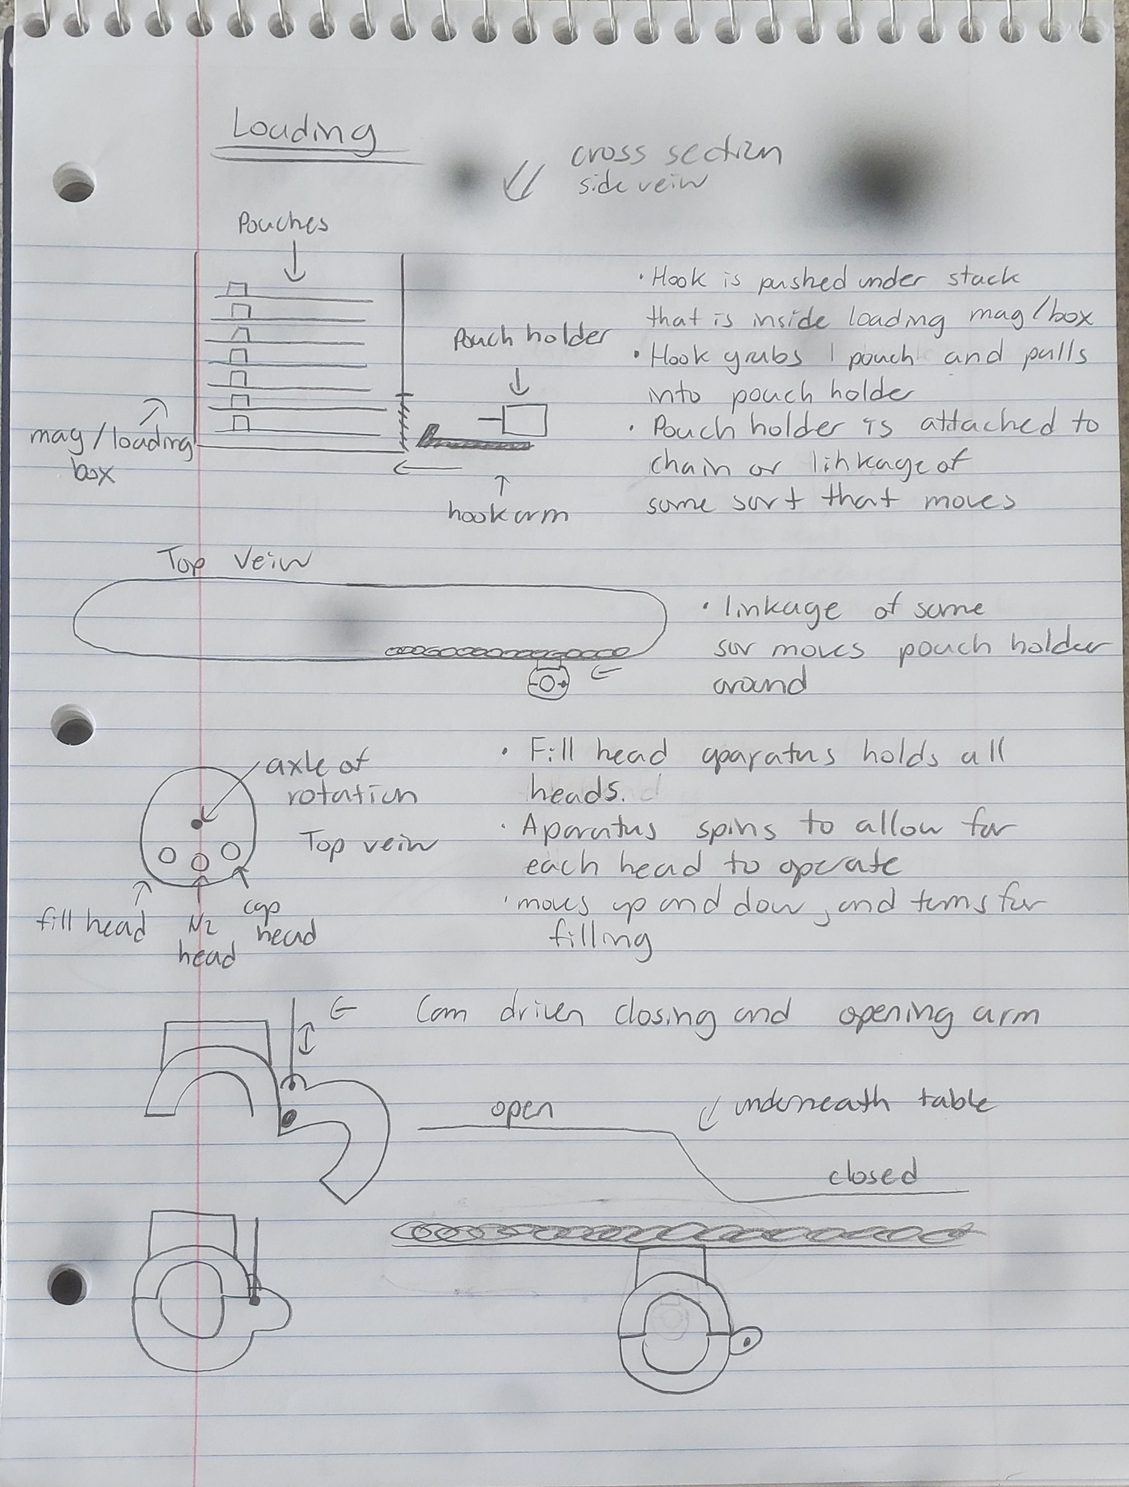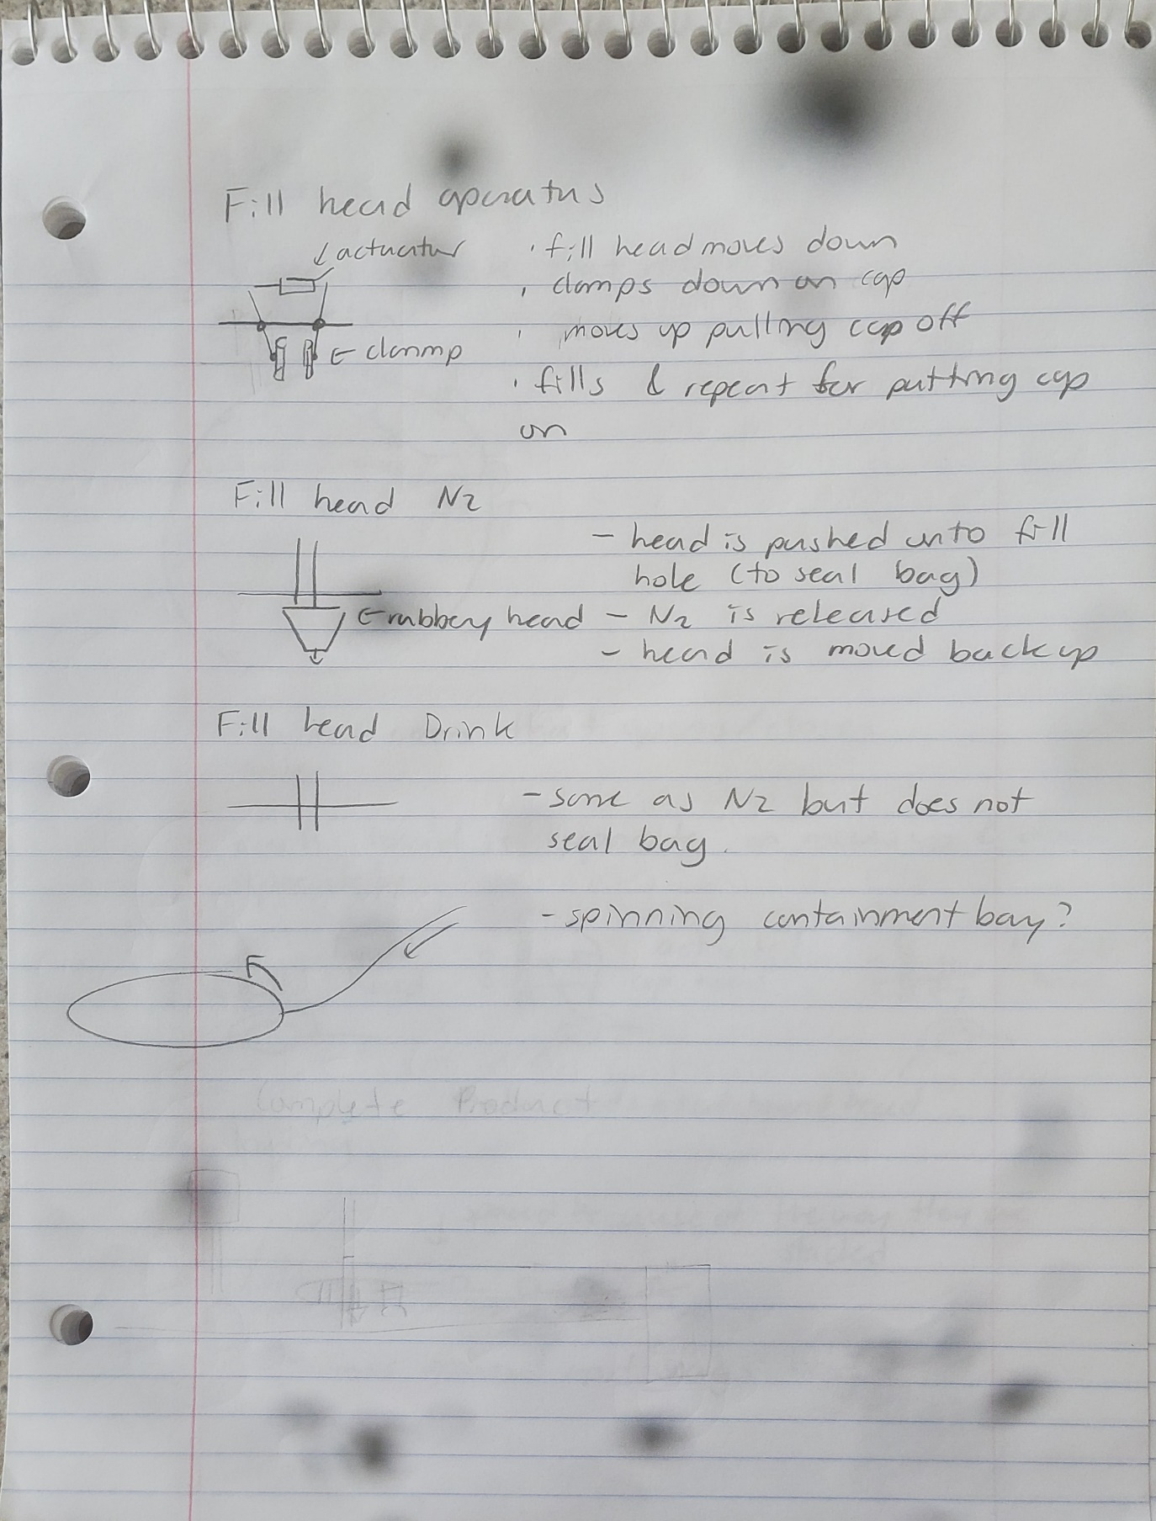

**--------------------------------------------------------- END OF DESIGN 3--------------------------------------------------------**

**Description:**

Like the design above. Except a disk is used to move pouches instead of track or linkage.

* Has a cam system that opens/closes pouch holder
* Fill heads have the same design but are individual instead of connected.
* Different loading systems are discussed.
  + This is system catches pouch with open clamp as pouch comes around.
  + Pouches are stacked a certain way so that they are spaced
* Cap Orientation Channel
  + Evergood has a air compressor.
  + This would utilize geometry and an air compressor to align caps.
  + The air is blown so that cap spins until it aligns with geometry. Cap then moves though channel.

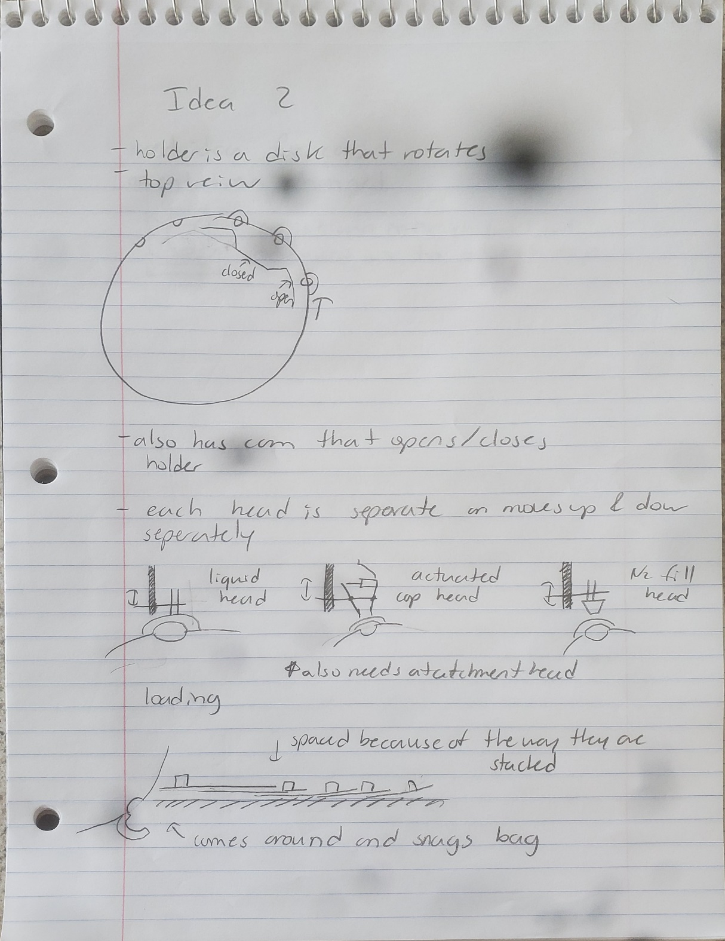

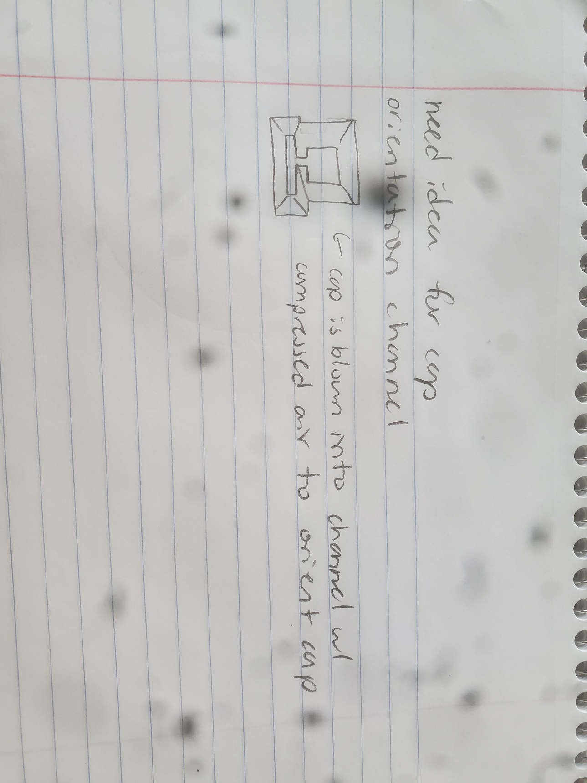

**--------------------------------------------------------- END OF DESIGN 4--------------------------------------------------------**

**Description:**

1. Loading mechanism
   1. Pouches stacked on slanted ramp
   2. Pouch opening facing up and towards the bottom of ramp
   3. Leading edge of pouch rests against opening of pouch below
   4. Bottom pouch is retrieved from stack by two roller wheels on the edge of the pouch
2. Pouch securing
   1. Metal teeth are mounted on a belt/segmented assembly
      1. When the belt is on a curve the space between the teeth is wider
      2. When the belt is straight the space between the teeth is exactly the width of the pouch opening and the pouch can be locked in place by a rail on the opposing side of the belt
      3. IR beam detectors can be placed horizontally above and below the position of the opening so that they are unbroken if the pouch is seated correctly
      4. An additional switch or beam detector will be present pointed upwards so that the machine can detect if a pouch is in the machine
3. Fill mechanism, 2 options – one for pouches without caps, one for pouches with caps
   1. Pouches without caps - the 3 functional tool heads of the assembly are separated
      1. The N2 head is on a vertical linear actuator and can raise and lower to interact with a pouch as it is fed through by the belt
      2. The wine spout is next and is on a similar vertical linear actuator setup as the N2
      3. The capping mechanism for pouches fed in without caps is described separately
   2. Pouches with caps – the 3 functional tool heads are on a single vertical linear actuator and can rotate or move back and forth relative to the pouch opening.
      1. The cap grabber will lower to the height of the smallest neck of the cap and then the grabbers will compress inward while rotating until the minimum distance between the grabbers is achieved
      2. The cap grabber will raise and move away and the N2 and wine heads will move into position and perform their functions
      3. The cap grabber will rotate to orient the cap to the proper direction and then push down to replace the cap
4. Capping mechanism (separate caps)
   1. The caps will be held on two rails that are at the minimum distance such that the caps slide in with the thinnest part of the neck in between the rails
   2. The rails are curved such that the caps slide downward toward the capping tool head
   3. Just before the capping tool a stopper gate is present to prevent caps from sliding down when the tool head moves downward
   4. The tool head has two rails that allow for 1 single cap to slide in then the stopper gate will close and the tool head pushes down to push the cap on the pouch

**--------------------------------------------------------- END OF DESIGN 5--------------------------------------------------------**